**Performance Analysis of an OFDM System with Different Modulation Techniques**

Project submitted by

Name: Rahat Kibria Bhuiyan

ID: 0423062532

Subject Name: Broadband & Wireless Communications

Subject code: EEE-6207

**Introduction**

Orthogonal Frequency-Division Multiplexing (OFDM) is a digital transmission technique widely employed in digital modulation for encoding binary data across multiple carrier frequencies. Developed by Robert W. Chang in 1966, OFDM has become a popular choice for broad-spectrum digital communication applications such as digital television, audio broadcasting, DSL internet access, wireless networks, power line networks, and 4G/5G mobile communications.

In the OFDM scheme, the incoming binary data stream is divided into multiple streams, and closely spaced orthogonal subcarrier signals with overlapping spectra are transmitted. Each subcarrier is modulated with bits from the incoming stream, allowing for parallel transmission of multiple bits. Demodulation relies on fast Fourier transform algorithms. Improvements to OFDM were introduced in 1971 by Weinstein and Ebert, incorporating a guard interval for enhanced orthogonality in channels affected by multipath propagation. Unlike single-carrier schemes, OFDM excels in coping with challenging channel conditions, such as attenuation of high frequencies in long copper wires, narrowband interference, and frequency-selective fading due to multipath. Its advantage lies in simplified channel equalization, treating OFDM as many slowly modulated narrowband signals rather than one rapidly modulated wideband signal. The low symbol rate enables the use of a guard interval, eliminating inter-symbol interference (ISI) and leveraging echoes and time-spreading for diversity gain.

In Coded Orthogonal Frequency-Division Multiplexing (COFDM), forward error correction and time/frequency interleaving are applied to the transmitted signal to address errors in mobile communication channels affected by multipath propagation and Doppler effects. COFDM, introduced by Alard in 1986, has found applications in Digital Audio Broadcasting. OFDM is commonly used in conjunction with coding and interleaving, making the terms COFDM and OFDM interchangeable in various practical applications.

OFDM offers remarkable advantages in digital communication. It boasts high spectral efficiency compared to other double sideband modulation schemes and spread spectrum techniques. Its adaptability to challenging channel conditions is notable, eliminating the need for complex time-domain equalization. OFDM demonstrates robustness against narrow-band co-channel interference, ISI and fading induced by multipath propagation. Leveraging fast Fourier transform, it allows for efficient implementation. Additionally, OFDM exhibits low sensitivity to time synchronization errors, eliminating the requirement for tuned sub-channel receiver filters found in conventional Frequency Division Multiplexing (FDM).

Despite its numerous advantages, it has some drawbacks also. It exhibits sensitivity to Doppler shift and is prone to frequency synchronization issues. A significant challenge lies in its high peak-to-average-power ratio (PAPR), necessitating the use of linear transmitter circuitry that often suffers from poor power efficiency. Additionally, the efficiency of OFDM is compromised by the inclusion of a cyclic prefix or guard interval, impacting its overall performance in certain operational scenarios. Various techniques, including carrier frequency offset correction and advanced signal processing algorithms, are employed to address these challenges and optimize the performance of OFDM systems.

**System Description**

In the depicted block diagram (fig-1) of a standard OFDM system, various components play integral roles. The system comprises several key elements, each serving a specific function. Below is a brief overview of these components.

S/P and P/S Shifters: These two shifters are employed to rearrange input data either into serial or parallel blocks, depending on the requirements of subsequent components.

Modulation: The parallel data undergoes mapping from bits to symbols based on the chosen modulation scheme (such as BPSK, QPSK, QAM, 16-QAM, etc.).

Inverse Fast Fourier Transform (IFFT): Each group of symbols is transformed from the frequency domain to the time domain.

Cyclic Prefix Addition: A cyclic prefix extension (guard interval) is added to each frame. It acts as a guard interval, eliminating Inter-Symbol Interference (ISI) and Inter-Carrier Interference (ICI) from the preceding symbol. Additionally, by repeating the symbol's end, it enables the modelling of linear convolution in a frequency-selective multipath channel as circular convolution. A discrete Fourier transform can efficiently transform this modelling into the frequency domain. As a result, the cyclic prefix facilitates simple frequency-domain processing tasks such as channel estimation and equalization, streamlining overall signal processing.

D/A and A/D Conversion: Digital signals, unsuitable for transmission through the medium, are converted into analog signals. At the receiver, analog signals are converted back to their digital form using analog-to-digital converters.

Channel Modelling: OFDM transmission propagates through a noisy channel with multipath fading. Let's consider, the time domain OFDM signal be , channel impulse response be ,

and the additive White Gaussian Noise (AWGN) be .

Received OFDM signal,

Cyclic Prefix Removal: The cyclic prefix extension is eliminated from each frame.

Fast Fourier Transform (FFT): The time domain data undergoes transformation to the frequency domain for subsequent processing.

Frequency Domain Channel Estimation: An estimation of the channel is computed and utilized to equalize the OFDM frame in the frequency domain. Channel estimation is crucial for mitigating distortions caused by factors such as multipath propagation, fading, and interference. By obtaining an accurate estimation of the channel, the receiver can apply appropriate equalization techniques to compensate for these distortions, ultimately improving the overall reliability and performance of the communication system. There are many different estimation methods are available. In this study, the Least-Squares Channel Estimation method is employed.

Demodulation: The symbols are mapped back into data bits.

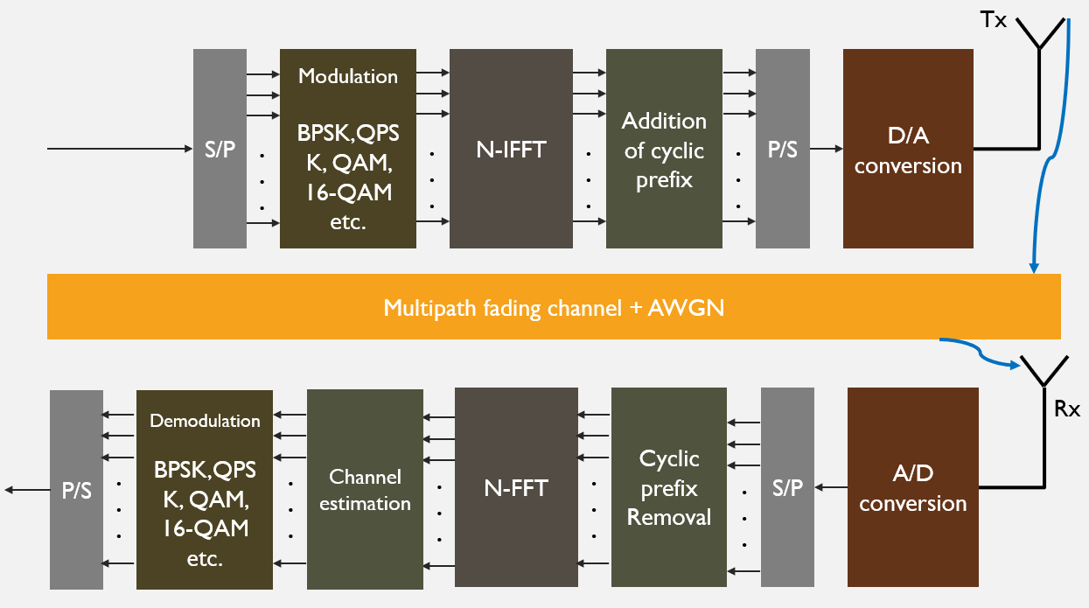

Fig1: Block diagram of an OFDM system

**Simulation Steps**

The entire simulation is conducted in MATLAB, employing a standard digital image as the message signal. Here are crucial parameters configured for the simulation:

SNR is set to be 10 dB.

64-point FFT is performed.

Size of cyclic prefix extension is 16

Number of multipath components is set to be 8

BPSK and QPSK modulation techniques are used.

Least-Square method is used for channel estimation.

**Results**

The performance and output is evaluated on BPSK and QPSK modulation

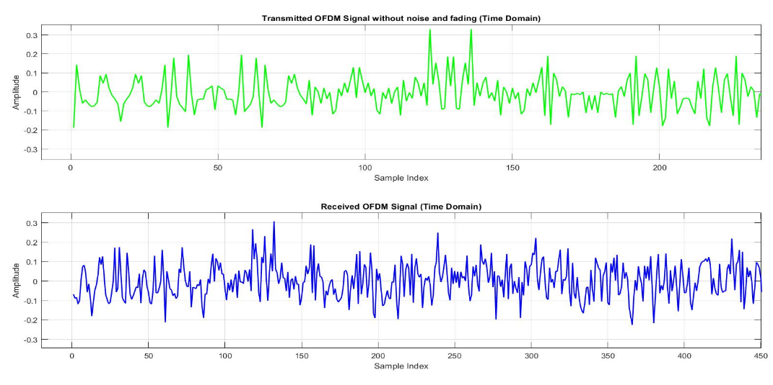

Fig-2: The transmitted and received OFDM signal through multipath AWGN channel

**BPSK**

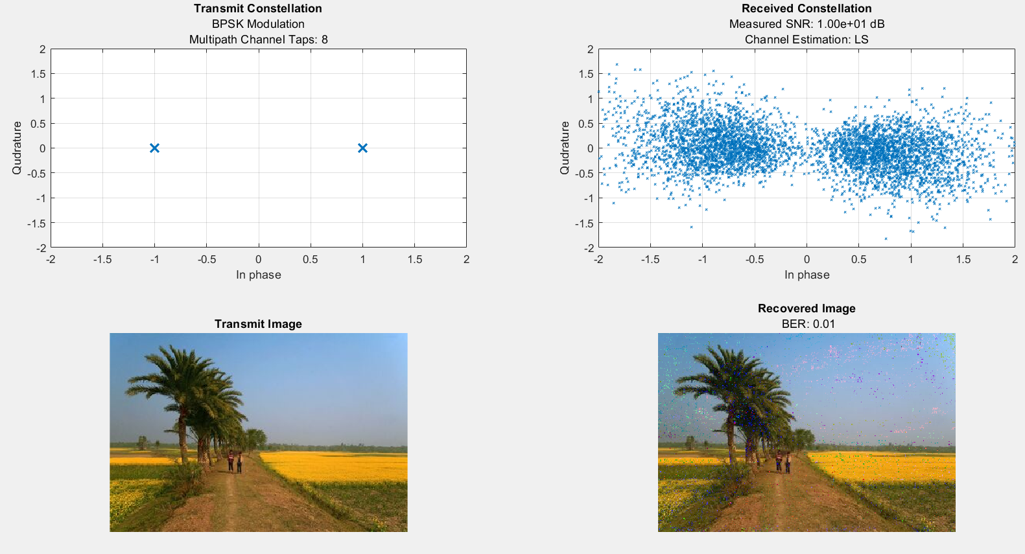

Fig: constellation diagram and images for BPSK modulation

Bit error rate and maximum PAPR (Peak to Average Power Ratio):

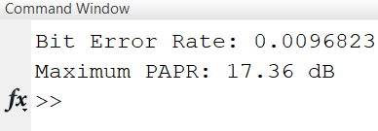

**QPSK**

Fig: constellation diagram and images for QPSK modulation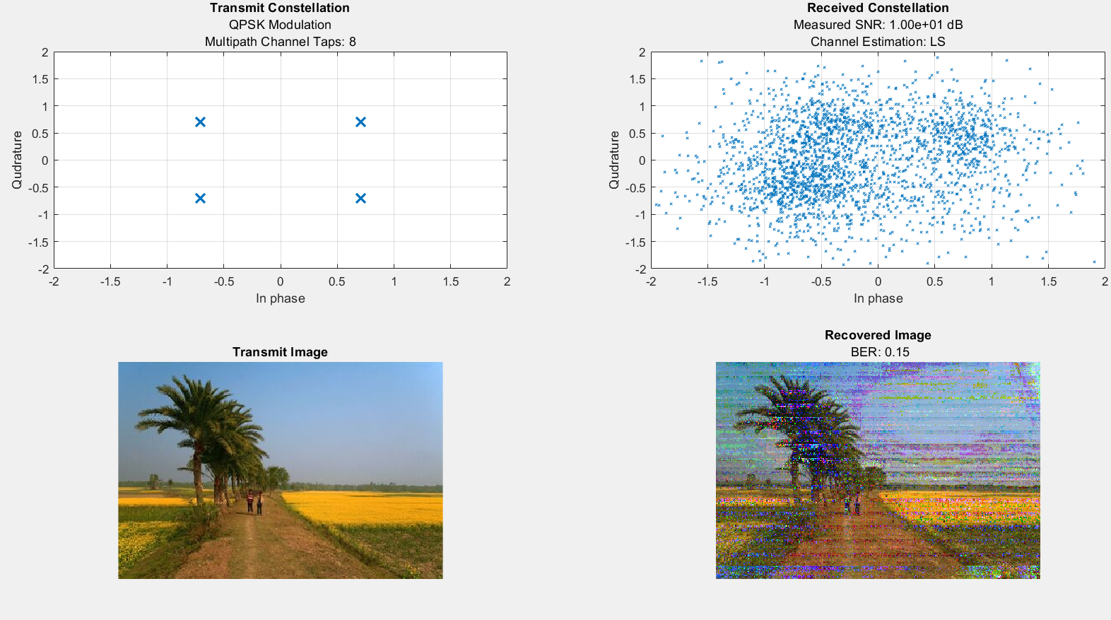

Bit error rate and maximum PAPR (Peka to Average Power Ratio):

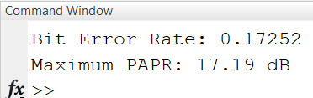

**BER Vs SNR**

Signal to noise ratio is iterated from -10 dB to 30 dB. The BER Vs SNR of the above mentioned modulation technique is plotted here.

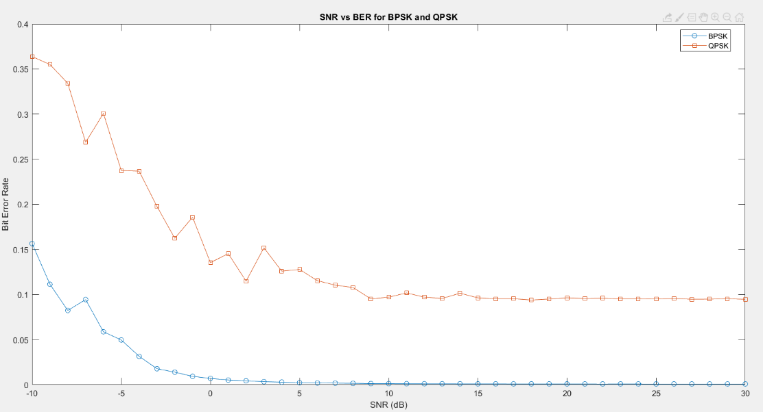

Fig; BER Vs SNR of BPSK and QPSK in OFDM system

Here we can see for a fixed SNR (snr is 10 dB) bit error rate is higher in QPSK in comparison to BPSK. Here are some possible reasons:

Higher Modulation Order: QPSK has a higher modulation order (4) compared to BPSK (2), meaning QPSK represents 2 bits per symbol, while BPSK represents 1 bit per symbol. Higher modulation orders generally lead to increased susceptibility to noise and channel impairments.

Symbol Distance: In the complex plane, the distance between symbols in QPSK is smaller than in BPSK. This smaller distance can make QPSK more vulnerable to errors caused by noise and fading.

**Conclusion**

In conclusion, this project delved into OFDM signal transmission and reception using MATLAB. It examined the influence of SNR on BER, considered multipath fading effects, and compared BPSK and QPSK modulation. The LS method was applied for channel estimation. The insights gained contribute to understanding OFDM system behaviour, providing a foundation for further optimizations in practical applications.